**Prometheus**

Prometheus is a software application user for event monitoring and alerting, time series database

It uses to Records any purely numeric time series Machine-centric and highly dynamic service-oriented architectures.

Below is the Architecture of the prometheus

HTTP server

Accepts-queries

Storage

Stores metrics data

Retriveal

pull metrics data

Time sereies database

Influxdb ,prometheus

Accepts Prometheus Queries by

Prometheus web UI

Data retrieval work by application and servers

Installation process of Prometheus

( [Download | Prometheus](https://prometheus.io/download/) )

1 sudo apt-get update ( updates of the ubuntu repository)

2 sudo useradd prometheus (add the user prometheus)

3 sudo mkdir /etc/prometheus ( create a directory prometheus in etc )

4 sudo mkdir /var/lib/prometheus ( create a directory prometheus in /var/lib )

5 wget https://github.com/prometheus/prometheus/releases/download/v2.38.0/prometheus-2.38.0.linux-amd64.tar.gz

6 sudo chown prometheus:prometheus /etc/prometheus ( owning of the prometheus in /etc folder)

7 sudo chown prometheus:prometheus /var/lib/prometheus ( owning of the prometheus in /var/lib folder)

8 tar -xvf prometheus-2.38.0.linux-amd64.tar.gz ( untar the prometheus)

9 mv prometheus-2.38.0.linux-amd64 prometheus-files ( moving the prometheus to prometheus-files)

10 sudo cp prometheus-files/prometheus /usr/local/bin/ ( copy of prometheus to bin folder)

11 sudo cp prometheus-files/promtool /usr/local/bin/ ( copy of promtool to bin folder)

12 sudo chown prometheus:prometheus /usr/local/bin/prometheus ( owning of the prometheus in /bin folder)

13 sudo chown prometheus:prometheus /usr/local/bin/promtool ( owning of the promtool in /bin folder)

14 sudo vi /etc/prometheus/prometheus.yml

( copy paste the below code)

global:

scrape_interval: 15s

external_labels:

monitor: 'prometheus'

scrape_configs:

- job_name: 'prometheus'

static_configs:

- targets: ['localhost:9090']

15 sudo chown prometheus:prometheus /etc/prometheus/prometheus.yml

16 sudo vi /etc/systemd/system/prometheus.service

( copy paste the below code)

[Unit]

Description=Prometheus

Wants=network-online.target

After=network-online.target

[Service]

User=prometheus

Group=prometheus

Type=simple

ExecStart=/usr/local/bin/prometheus \

--config.file /etc/prometheus/prometheus.yml \

--storage.tsdb.path /var/lib/prometheus/ \

--web.console.templates=/etc/prometheus/consoles \

--web.console.libraries=/etc/prometheus/console_libraries

[Install]

WantedBy=multi-user.target

17 sudo systemctl daemon-reload

18 sudo systemctl start prometheus

19 sudo systemctl status prometheus

Now in your browser navigate to

Take public_ip of the instance paste in browser with port no

Public_ip:9090

The dashboard of the prometheus will look like as shown below

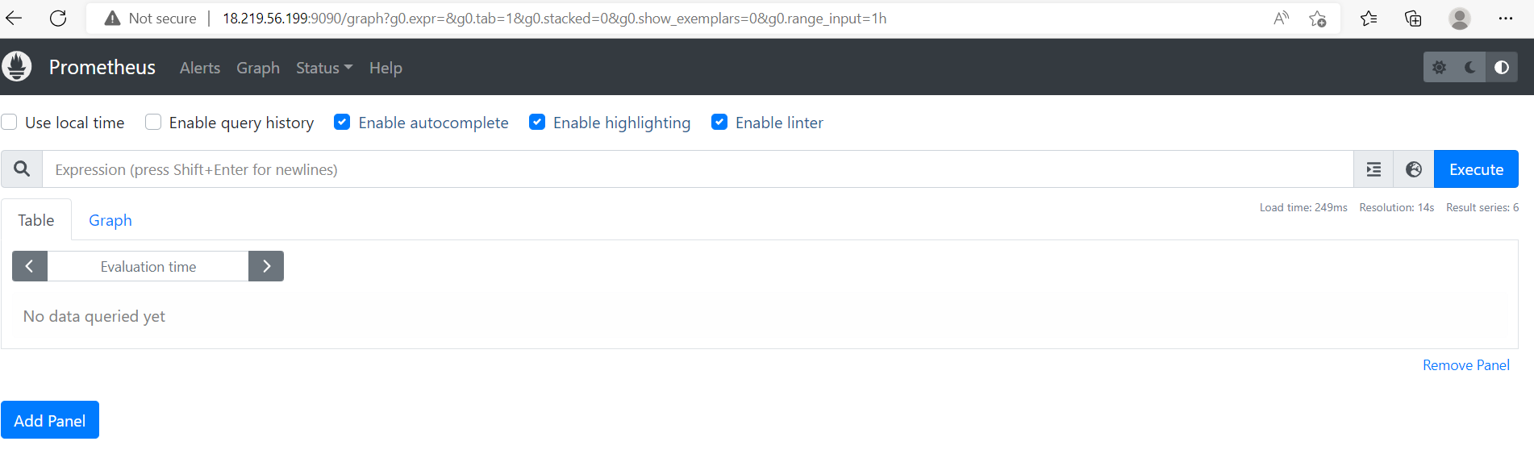

**Node Exporter**

Node Exporter is a Prometheus exporter for server level and OS level metrics with configurable metric collectors. It helps us in measuring various server resources such as RAM, disk space, and CPU utilization.

Installation process of Node-exporter

i) We are ready to install Node Exporter binaries.

1. wget https://github.com/prometheus/node_exporter/releases/download/v1.5.0/node_exporter-1.5.0.linux-amd64.tar.gz

2. tar xzf node_exporter-1.5.0.linux-amd64.tar.gz

3 cd node_exporter-1.5.0.linux-amd64

4. sudo cp node_exporter /usr/local/bin/

5. cd ..

6. rm -rf node_exporter-1.5.0.linux-amd64.tar.gz node_exporter-1.5.0.linux-amd64.tar.gz

7. Now let’s create a user for Prometheus Node Exporter

sudo useradd --no-create-home --shell /bin/false node_exporter

8. sudo chown node_exporter:node_exporter /usr/local/bin/node_exporter

ii) Configure a service. Create /etc/systemd/system/node-exporter.service.

sudo vi Create /etc/systemd/system/node-exporter.service

( go to it and copy paste the below content in it)

[Unit]

Description=Prometheus Node Exporter Service

After=network.target

[Service]

User=node_exporter

Group=node_exporter

Type=simple

ExecStart=/usr/local/bin/node_exporter

[Install]

WantedBy=multi-user.target

iv) Configure systemd.

1 sudo systemctl daemon-reload

2 sudo systemctl enable node-exporter

3 sudo systemctl start node-exporter

4 sudo systemctl status node-exporter

** Edit /etc/prometheus/prometheus.yml file.

sudo vi /etc/prometheus/prometheus.yml

(and copy paste the code)

global:

scrape_interval: 15s

external_labels:

monitor: 'prometheus'

scrape_configs:

- job_name: 'node_exporter'

static_configs:

- targets: ['public_ip:9100']

** Restart Prometheus service.

sudo systemctl restart prometheus

Now in your browser navigate to

Take public_ip of the instance paste in browser with port no

Public_ip:9100

The dashboard of the prometheus will look like as shown below

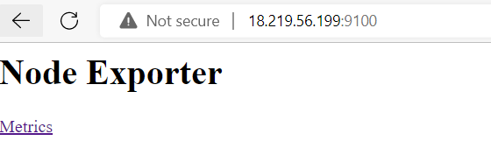

**Grafana**

Grafana is a multi-platform open-source analytics and interactive visualization web application. It provides charts, graphs, and alerts for the web when connected to supported data sources.

Below is the Architecture of the Grafana

Data Producer

Grafana

Dashboard

DATA Source

InfluxDb,Prometheus

Jenkins server, Kubernetes, virtual machines etc

Grafana queries from data sources

Ins

installation process of Grafana

1 sudo apt-get install -y adduser libfontconfig1

2 wget <https://dl.grafana.com/enterprise/release/grafana-enterprise_9.1.1_amd64.deb>

3 sudo dpkg -i grafana-enterprise_9.1.1_amd64.deb

4 sudo /bin/systemctl daemon-reload

5 sudo /bin/systemctl enable grafana-server

6 sudo systemctl start grafana-server

7 sudo systemctl status grafana-server

** Edit /etc/prometheus/prometheus.yml file.

sudo vi /etc/prometheus/prometheus.yml

(and copy paste the code)

global:

scrape_interval: 15s

external_labels:

monitor: 'prometheus'

scrape_configs:

- job_name: 'grafana'

static_configs:

- targets: ['public_ip:3000']

** Restart Prometheus service.

sudo systemctl restart prometheus

Now in your browser navigate to

Take public_ip of the instance paste in browser with port no

Public_ip:3000

On dashboard grafana CLI use the details

grafana default username : admin

password : admin

The dashboard of the prometheus will look like as shown below

